**Microsoft INF212x – Microsoft Windows Server 2016 Fundamentals: Directory Services**

This course is part of a larger series of courses on Windows Server 2016 Fundamentals.

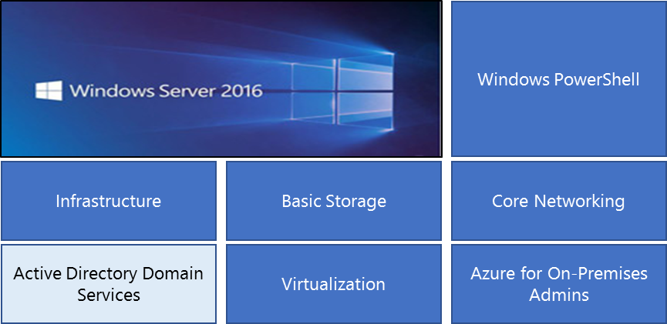

**Overview:**

What you will learn in this course:

* How to create and configure user, group, and computer accounts.
* How to implement Group Policy Objects to enforce standard processes in your organization.

**Modality**:

* Self-paced with a moderated discussion board.
* Students will complete hands-on labs in an online virtual environment.
* A Verified Certificate is available after obtaining 70% on the course graded events.

**Audience:**

* Windows Server IT Administrators who are beginning their careers and need task-oriented training on fundamental day-to-day skills.
* IT Administrators who are looking to branch out into the Windows Server Operating System.
* IT Administrators that want to demonstrate new skills for job advancement or certification testing. Specifically, the [MCSA: Windows Server 2016](https://www.microsoft.com/en-us/learning/mcsa-windows-server-2016-certification.aspx) certification.

**Course Prerequisites:**

* You should have some general understanding of Windows Server, including Server Manager, server roles and features. This information is included in the [Microsoft Technology Associates](https://www.microsoft.com/en-us/learning/mta-certification.aspx) certification.
* Windows PowerShell will be the tool of choice when implementing the features in this course. Learners should have a good foundation in accessing and using simple Windows PowerShell commands.
* There are many resources available for learning the skills necessary to be successful in this course. For example, [Windows Server Administration Fundamentals](https://mva.microsoft.com/en-US/training-courses/windows-server-administration-fundamentals-8477?l=LaRRbeXz_5004984382).

**Module 1 - User Accounts**

**IT Administrator Tasks:**

* Configure and manage user accounts.
* Configure and manage user passwords with group policy.
* Configure and manage fine-grained password policies.

**Topics**: User Accounts, Creating User Accounts, Account Attributes, Use Account Templates, User Account Best Practices, User Password Policies, Password Policy Settings, Account Lockout Policy Settings, Fine-Grained Password Policies

**Demonstrations**: User Account, User Templates, User Passwords

**Labs:** User Accounts (ADAC), User Accounts (PowerShell), User Templates, Group Policy Password Settings, Fine-Grained Password Settings

**Module 2 - Group Accounts**

**IT Administrator Tasks:**

* Create groups and ensure the proper scope is applied.
* Manage the built-in groups and apply best practices.

**Topics**: Group Types, Distribution vs. Security Groups, Group scopes, Domain-Local Groups, Global Groups, Universal Groups, Group Naming Conventions, Group Nesting, Protected User Group, Special Identities, Local Groups, Custom Groups

**Demonstrations**: Group Nesting

**Labs:** Investigate Groups, Group Accounts (ADAC and PowerShell), Group Nesting, and Group Inheritance

**Module 3 - Computer Accounts**

**IT Administrator Tasks:**

* Configure and manage computer accounts.
* Fix broken channel problems, and join computers to the domain.

**Topics**: Computer Accounts, Computer Organization, Computer Naming, Computer Permissions, Pre-Stage Computers, Secure Channels, Broken Channels, Resetting the channel, Offline Domain Join

**Demonstrations**: Broken Computer Channels

**Labs**: Computer Accounts, Computer Delegation, Domain Join, and Offline Domain Join

**Module 4 - Group Policy**

**IT Administrator Tasks:**

* Configure group policy settings, preferences, and central store.
* Manage group policy permissions, delegation, and templates,

**Topics**: Group Policy Objects and Settings, Group Policy Templates vs Containers, Group Policy Versioning, Linking GPOs, GPO Updating and Refresh, GPO Precedence, Inheritance Blocking and GPO Enforcement, Group Policy Preferences, Group Policy Permissions, Delegating GPOs, Central Store Management, Templates and Filtering

**Demonstrations**: Group Policy Preferences, Central Store

**Labs**: Simple GPOs, Group Policy Preferences, GPO Templates, GPO Management, Central Store